[ Insert official UPAEP logo ]
UPAEP · Decanato de Ingenierías
EVIDENCE — US06-T2
Configure the cloud service and device authentication
SmartGreenAI: Cilantro Crop

1. Task information
Task ID | US06-T2
User Story | US-06 — Transmit IoT measurements to the cloud
Sprint | Sprint 2 (2026-09-21 – 2026-10-09)
Week | Week 1
Responsible | Vicente Rocha Alfaro
Peer reviewer | Oscar Abraham Talavera Nava
Planned / actual hours | 2 h / 2 h
Completed on | September 25, 2026
Status | Done

2. Task description
Set up the cloud service or broker that receives the data, create credentials for each device (token or API key) and document the configuration steps so another member can reproduce them.

3. Completion conditions
✓ Condition 1: Cloud service/broker is running and reachable.
How it was verified: The cloud service (Express API + PostgreSQL) is running and reachable: GET /api/health answers status "ok" with database.connected = true (version 1.0.0).
Health check (attached: US06-T2_Configure_Cloud_Service_Device_Authentication_5.txt)
GET /api/health
→ HTTP 200 OK (8 ms)
{
"status": "ok",
"version": "1.0.0",
"environment": "development",
"uptime_seconds": 62,
"database": {
"connected": true
},
"devices": {
"active": 1,
"online": 1
},
"timestamp": "2026-09-29T04:17:43.230Z"
}

✓ Condition 2: Each test device has its own token or API key.
How it was verified: Each device has its own API key: dev-node-01 (the development node) and the new test node registered below each authenticate with their own key, and a request without a key is refused. The database keeps only a 64-character SHA-256 hash of each key.
Device credentials (only the SHA-256 hash of each key is stored) (3 rows; US06-T2_Configure_Cloud_Service_Device_Authentication_1.csv)
id | name | is_active | api_key_hash | hash_len | last_seen
dev-node-01 | Nodo Central Invernadero 1 | true | 2586c11fce2b88656a7a8dc6d536017da97eb17877839493e0d240c72… | 64 | 2026-09-29T04:17:43.200Z
dev-node-mum60kx3 | Matrix probe node | false | 6082730603b9cd963a85428520099b376adab05ce8a05e36d91f0f379… | 64
dev-node-mum60kxk | Matrix probe node | false | 3a4b72878f6d06bd5935b779256946d73aa79eb5b010bce1fe2a0ff8f… | 64
SQL: SELECT id, name, is_active, api_key_hash, length(api_key_hash) AS hash_len, last_seen FROM devices ORDER BY id
Heartbeat of each device with its own key, and without a key (attached: US06-T2_Configure_Cloud_Service_Device_Authentication_6.txt)
POST /api/devices/heartbeat
apikey: sec_io…
{
"firmware": "esp32-smartgreen-1.0.0"
}
→ HTTP 200 OK (16 ms)
{
"device_id": "dev-node-01",
"status": "ONLINE",
"actuators_refreshed": 0,
"server_time": "2026-09-29T04:17:45.091Z",
"offline_after_minutes": 5
}
POST /api/devices/heartbeat
apikey: sec_io…
{
"firmware": "test"
}
→ HTTP 200 OK (17 ms)
{
"device_id": "dev-test-06t2",
"status": "ONLINE",
"actuators_refreshed": 0,
"server_time": "2026-09-29T04:17:45.075Z",
"offline_after_minutes": 5
}
POST /api/devices/heartbeat
{}
→ HTTP 401 Unauthorized (3 ms)
{
"status": 401,
"code": "ERR_AUTH_REQUIRED",
"message": "A device API key is required in the \"apikey\" header.",
"details": []
}

✓ Condition 3: Configuration steps are documented so another member can repeat them.
How it was verified: Configuration steps that any member can repeat: (1) start the database and the API (npm run db:up, db:schema, db:seed, npm run dev — see README.md and docs/DEPLOYMENT.md); (2) sign in as Administrator and open IoT devices → Register device; (3) copy the key shown once; (4) write it in iot/esp32_smartgreen/secrets.h (DEVICE_API_KEY) or pass it to the simulator (--key); (5) the device authenticates with the apikey header. Steps 2–3 are shown in Figures 1–2.
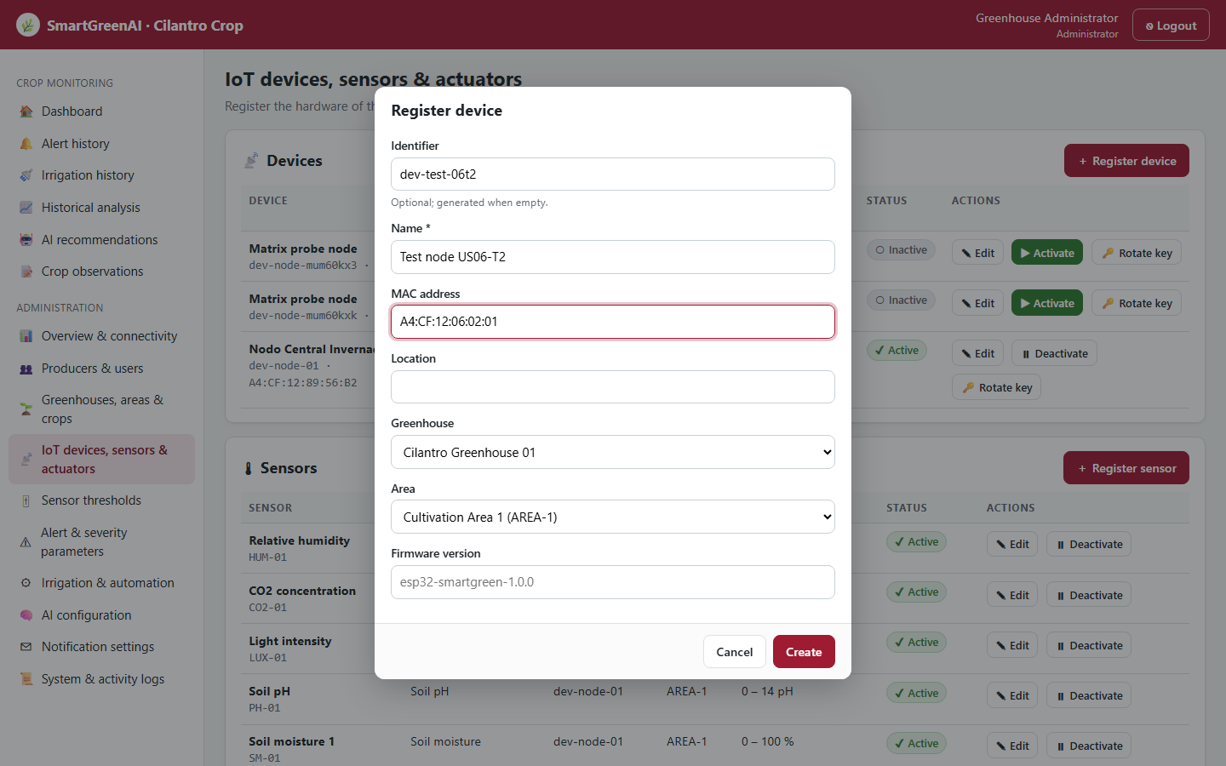
Figure US06-T2-1. Step 1: Administrator → IoT devices → Register device, filling the form of a new test node. (US06-T2_Configure_Cloud_Service_Device_Authentication_3.png)
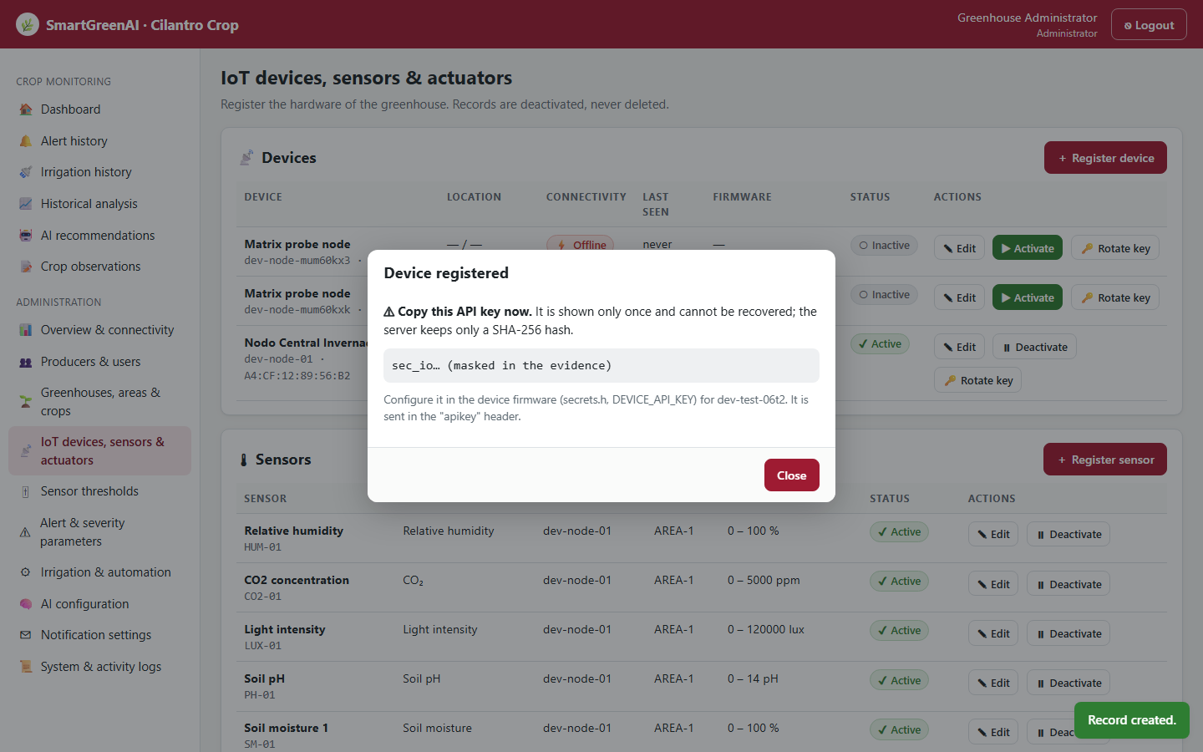
Figure US06-T2-2. Step 2: the platform generates the device API key and shows it only once (masked in this capture). (US06-T2_Configure_Cloud_Service_Device_Authentication_4.png)
iot/esp32_smartgreen/secrets.h.example — lines 1–17
// Copy this file to secrets.h (it is git-ignored) and fill in your values.
#pragma once
#define WIFI_SSID "your-wifi"
#define WIFI_PASSWORD "your-wifi-password"
// Base URL of the API, without a trailing slash. Use HTTPS in production (NFR-09).
#define API_BASE_URL "https://your-server.example.com/api"
// Plain API key shown ONCE when the device was registered (Administrator > IoT devices).
// Development key of dev-node-01 from database/seed.sql:
#define DEVICE_API_KEY "sec_iot_dev_node_01_smartgreen_team3"
// Optional: root CA certificate of your server (PEM) to validate HTTPS.
// Without it the firmware uses setInsecure(), acceptable only for development.
// #define API_ROOT_CA "-----BEGIN CERTIFICATE-----\n...\n-----END CERTIFICATE-----\n"

✓ Condition 4: Evidence: Cloud service running; configuration document with screenshots.
How it was verified: The service is running (health check) and the configuration document with screenshots is this section. The test node was deactivated after the check.

4. Attached files
- US06-T2_Configure_Cloud_Service_Device_Authentication_1.csv
- US06-T2_Configure_Cloud_Service_Device_Authentication_2.sql
- US06-T2_Configure_Cloud_Service_Device_Authentication_3.png
- US06-T2_Configure_Cloud_Service_Device_Authentication_4.png
- US06-T2_Configure_Cloud_Service_Device_Authentication_5.txt
- US06-T2_Configure_Cloud_Service_Device_Authentication_6.txt

5. Traceability
Related requirements | FR-05, FR-24, NFR-05, NFR-08, NFR-09
Implementation | See docs/TRACEABILITY.md
Verification | See docs/TRACEABILITY.md

6. Sign-off
Role | Name | Date | Signature
Responsible | Vicente Rocha Alfaro | September 25, 2026
Peer reviewer | Oscar Abraham Talavera Nava | September 25, 2026
Product Owner acceptance | Alexis Enrique Valle Parra | September 25, 2026
Approval record: Daily Meeting 1 of Sprint 2 (Monday, September 21, 2026): the team agreed the stack (PostgreSQL, Node.js + Express, JWT sessions and device API keys) and the measurement payload (sensor_id, value, unit, recorded_at in UTC).

